1. Find the pnames of parts for which there is some supplier.

2. Find the snames of suppliers who supply every part.

3. Find the snames of suppliers who supply every red part.

4. Find the pnames of parts supplied by Acme Widget Suppliers and by no one else.

5. Find the sids of suppliers who charge more for some part than the average cost of that part (averaged over all the suppliers who supply that part).

6. For each part, find the sname of the supplier who charges the most for that part.

Tables

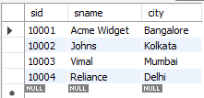select * from supplier_172;

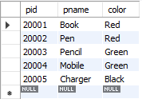select * from parts_172;

select * from catalog_172;

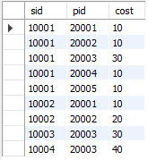

Query 1.

select distinct p.pname from parts_172 p,catalog_172 c where p.pid=c.pid;

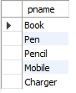

Query 2.

select distinct s.sname from supplier_172 s where Not exists(select p.pid from parts_172 p where not exists(select c.sid from catalog_172 c where c.sid=s.sid and p.pid=c.pid));



Query 3.

select s.sname from supplier_172 s where Not exists(select p.pid from parts_172 p where p.color='red' and Not exists(select c.sid from catalog_172 c where c.sid=s.sid and p.pid=c.pid));



Query 4.

select p.pname from parts_172 p,catalog_172 c,supplier_172 s where c.sid=s.sid and p.pid=c.pid and s.sname='Acme Widget' and not exists( select * from catalog_172 c1,supplier_172 s1 where c1.sid=s1.sid and p.pid=c1.pid and s1.sname!='Acme Widget');



Query 5.

select distinct c.sid from catalog_172 c where c.cost>(select avg(c1.cost) from catalog_172 c1 where c1.pid=c.pid);



Query 6.

select p.pid,s.sname from parts_172 p,catalog_172 c,supplier_172 s where c.sid=s.sid and p.pid=c.pid and c.cost=(select max(c1.cost) from catalog_172 c1 where c1.pid=p.pid);

